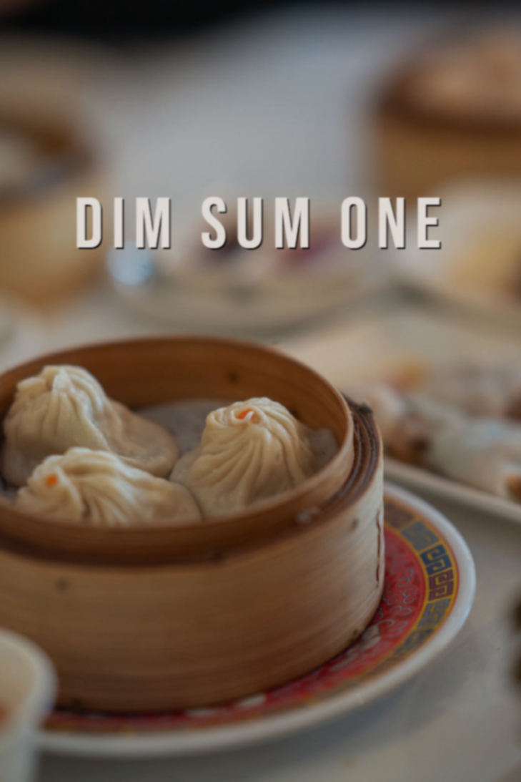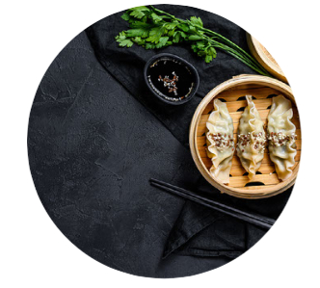

I liked the environment though it was a bit noisy. The dining hall looked nice with some lanterns.

*How did the spring rolls* ***look*** *and* ***taste?***

*What was the* ***texture*** *of the spring rolls?*

*How did the vinegar* ***smell****?*

What a disappointment!!! (7 days ago)

**Chris**



A place is more than what you can SEE. Keep your mind open and try to HEAR, SMELL, TASTE and FEEL it.

Task 2: Revise Sam’s dining review by adding more **sensory descriptions** to help readers understand his excitement. The sticky notes and symbols may help you.



**smell of** **food and drinks**

Curriculum Development Institute

Education Bureau HKSAR ©2022

Task 3: Chris had a terrible dining experience at *Dim Sum One*last week. Write a short review on the dining environment and food for him/her.



***Dim Sum One***

Task 1: Complete the bubbles below with words to describe what you could **see**, **hear**, **smell**, **taste** and **feel** at *Dim Sum One*.

***Topic***

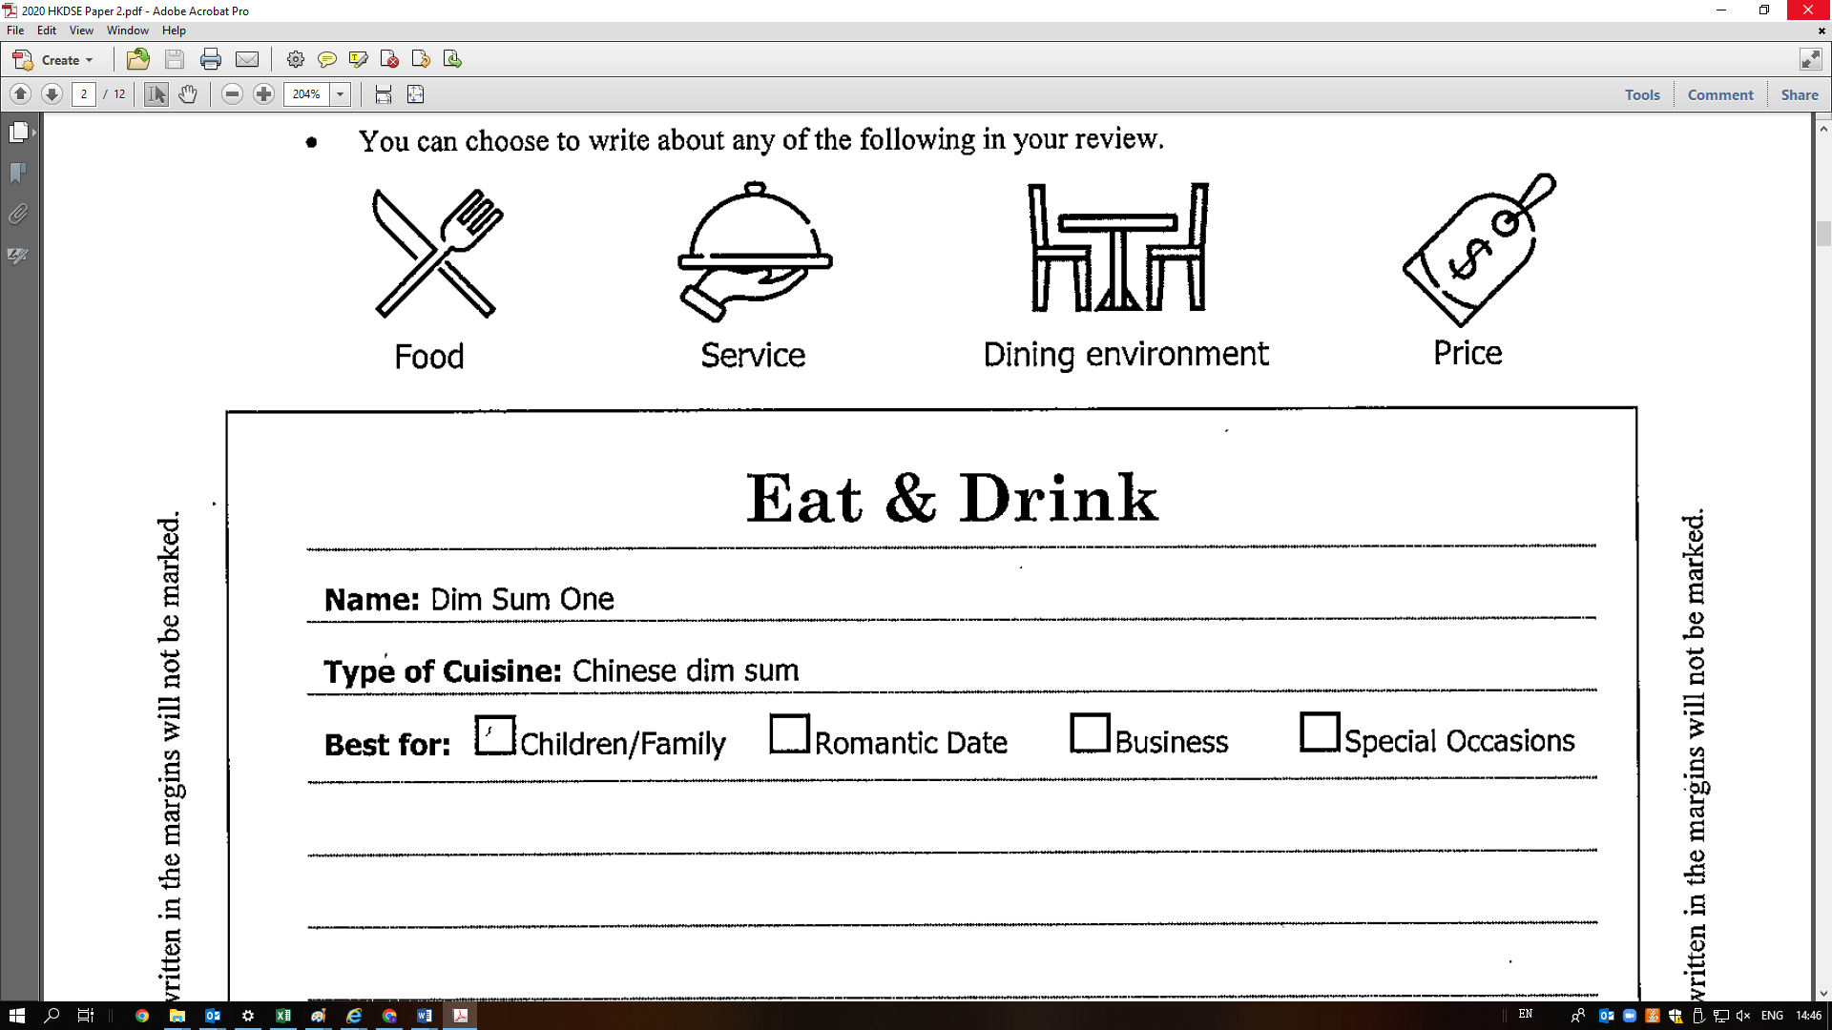

*Writing topic taken from Paper 2 of the 2020 HKDSE English Language Examination ©HKEAA*

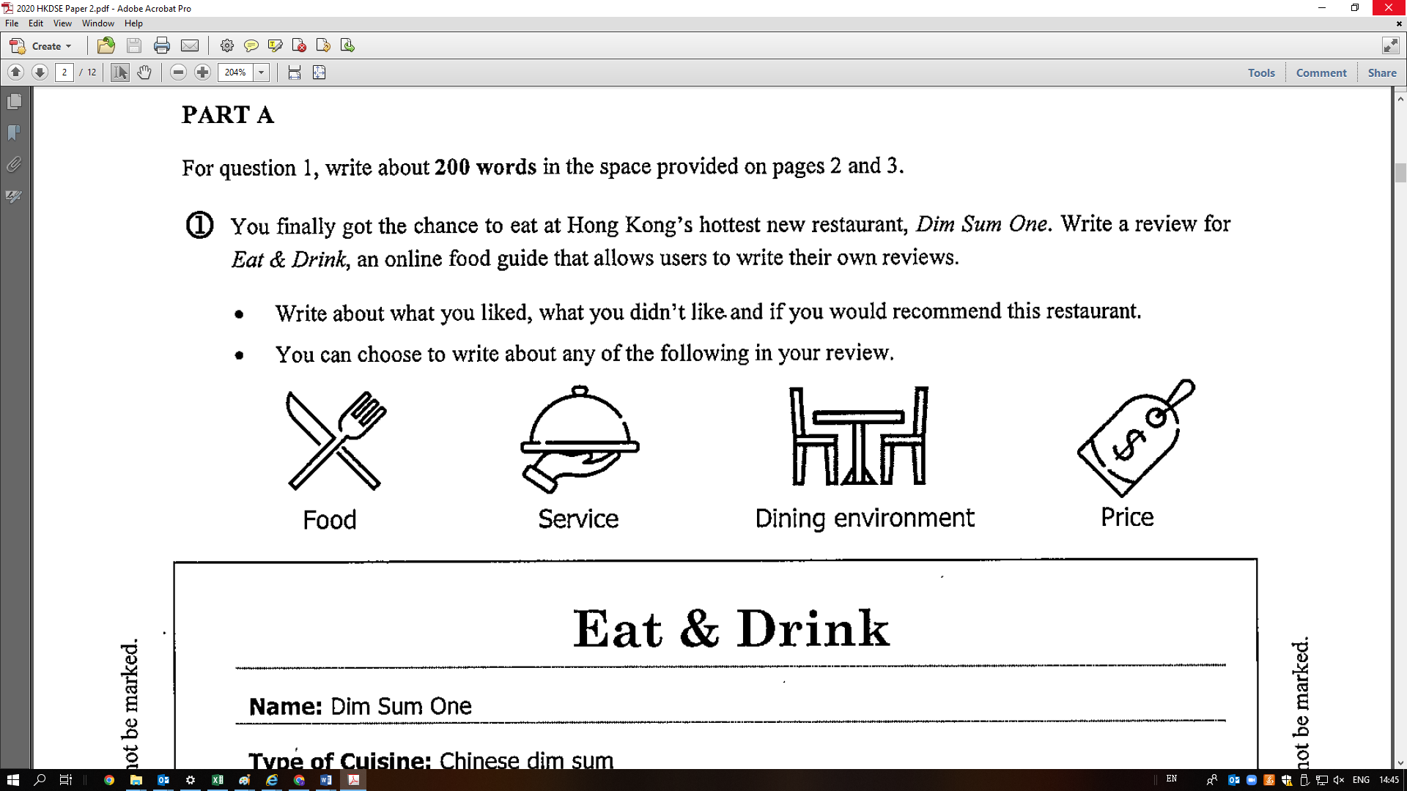



I visited *Dim Sum One* last week. The dining hall was pretty small. At the time I arrived, it was _____________ with customers sitting back to back. The __________voices of diners filled the whole restaurant and definitely ruined my appetite.

I only ordered the signature dishes – spring rolls and baked barbecued pork buns. To my disappointment, the spring rolls were not ____________ at all. They were so _________ and _________ that I could tell they were prepared hours ago. The baked barbecued pork buns were no better. They were _______ , _________ and ________ as rocks. I wondered why people recommended them and described them as ‘steaming hot and tasty with a crispy top’! What’s worse, the filling smelt ___________ and I spat the meat out in disgust after the first bite. I complained to the manager and swore that I would never set foot in this restaurant again.



An amazing dining experience (6 days ago)



**Sam**

I liked the environment. The dining hall was _______________ with rows of ___________ lanterns hanging down from the ceiling. The ______________ atmosphere made the place an ideal location for gatherings with family and friends. Though sometimes it could get a bit too _____________ for me tohear my friends clearly, I think that’s typical of a popular Chinese restaurant.

The food did not disappoint me. The ______________ spring rolls were so _____________ . They were_______ on the outside and__________on the inside. The vinegar dip might smell a bit ____________ , but it was a perfect match for the spring rolls and increased my appetite.



I liked the food, too. The spring rolls were really yummy. They went well with the vinegar dip.



*How did the dining hall* ***look?***

*What could you* ***see?***

*What* ***sound*** *did you* ***hear?***



***The texture and temperature*** *of food and drinks can be felt by* ***hand*** *and* ***mouth.***

**texture and temperature of food and drinks**



**taste and flavour of food and drinks**

**décor, colour of furniture, food presentation**

**Sam’s draft dining review:**

**environment and human noise/sounds in the restaurant**

